# A

# B

# Overall System Description

## General System Description

In this project, we created a robot which is controlled by a remote user using a telecontroller. The robot is able to play hockey game within the standarts declared in last semester. Our robot contains different subsystems corresponding their functions, power supply, telecommunication, shooting, motion and detection.

## Individual System Description

### d

### Communication and Telecontroller Subsystem

#### Communication Link for Sending Commands

As a company, we see the telecommunication system as the main design objective of this project. For this purpose, we developed unique communication link for sending commands to a remote location which will become the robot later.

##### The Algorithm

In this communication link, we utilized an RF tranciever module, NRF24L01 and Arduino development boards for both the transmitter and receiver. In the controller side, the command from the user is taken with a joystick. Then the joystick position is read by an Arduino Uno. Then using SPI serial interface, the generated command signal is sent the RF module and finally the RF signal is sent the antenna. At the receiver side, the robot, the same NRF24L01 module receives the RF signal and again using SPI serial interface, the received signal is sent to the Arduino Mega. Then, the received signal is interpreted via Arduino and the respective command is decided. Afterward, the command is executed. . For better understanding, a simplified functional block diagram of the communication link for sending commands is given in Figure XX.

We used a 5 bit register to describe different commands. Whenever an assigned bit is 1, the corresponing command is sent via NRF module as 5 bit register. Bit sequence can be seen in Table XX. Example bit sequences is given in Figure XX.

Table 3‑1 Bit sequences for each individual command

|  |  |  |  |  |
| --- | --- | --- | --- | --- |
| Shoot | Forward | Backwards | Right | Left |
| 10000 | 01000 | 00100 | 00010 | 00001 |

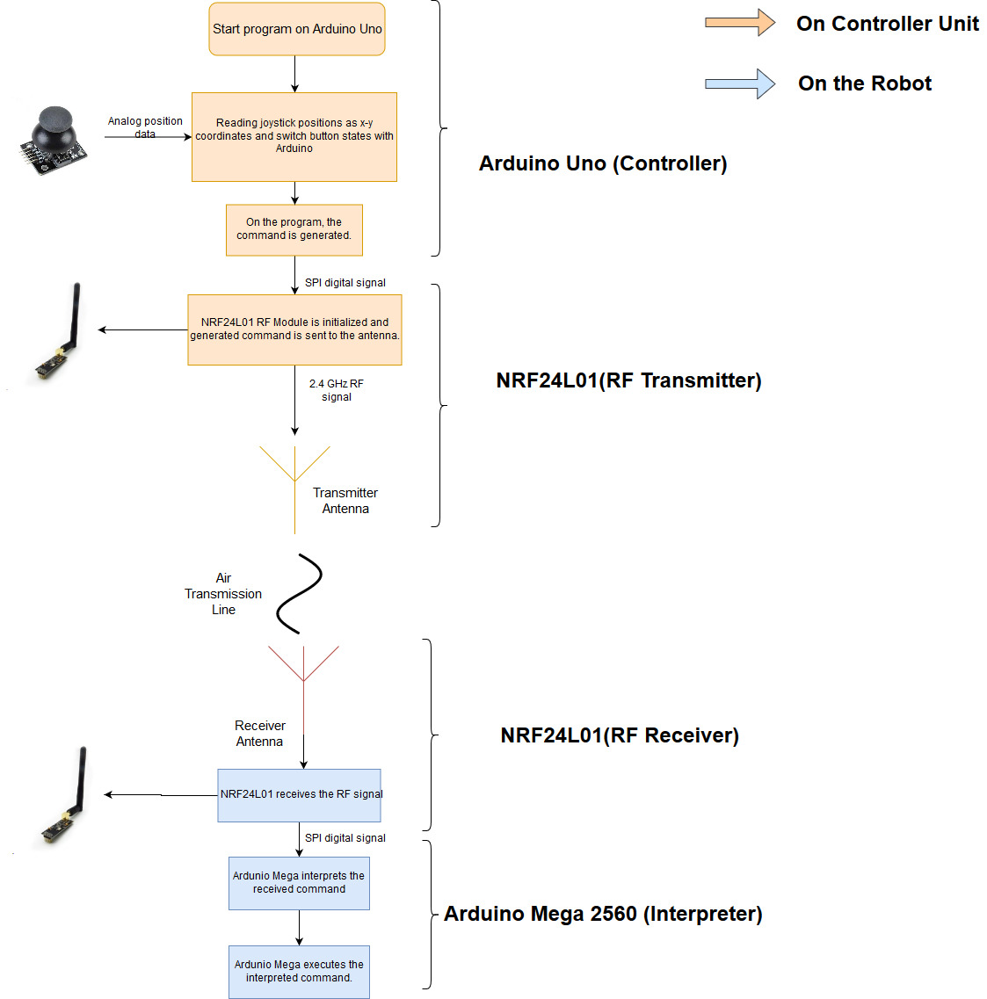

Figure 3.1 Block Diagram of the telecommunication subsystem for sending commands

##### Joystick (User Interface)

To receive commands from the user, we implemented a joystick which is composed of two potetiometers and a push button. Depending on the position of the joystick nipple, an analog signal is generated from the potentiometer and then this analog signal is received at the Arduino Uno. This part completes the user interface of the controller subsystyem. A photo of the joystick can be seen in Figure XX

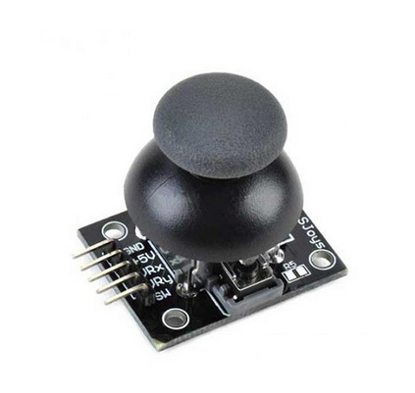

Figure 3.2 The joystick

##### Arduino uno (Controller)

On the Arduino, depending the analog signal values from the joystick, the bit sequence is generated (explained at the algorithm part). The program on the Arduino controls the RF tranciever module, NRF24L01, and writes the bit sequence values to the module. We used RF24.h and nrf24l01.h libraries to control the module.[n <https://github.com/nRF24/RF24>]

The Arduino codes for reading the joytick values and controlling the RF module is given in Figure XX.

##### NRF24L01 (RF Tranciever)

To send the bit seqeunces that carries the command information, we used NRF24L01 module which uses 2.4 GHz RF signal to communicate (Figure XX). This module can be used as both transmitter and receiver. On the controller side, the module is used as only transmitter and on the robot side, the module used only as receiver. The selection between transmitter and receiver modes are declared in the program code.

The modules come with an dipole antenna. However, the antenna can be replaced. 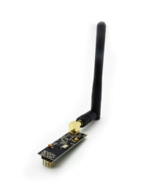

Figure 3.3 NRF24L01 RF Module

After sending and receiving the message from the NRF24L01, the message is transmitted to the robot and ready to be interpreted at the Arduino Mega which is located at the robot.

##### Arduino Mega 2560 (Interpreter)

After the signal is received by the NRF24L01 module, the signal with command infformation is sent to the Arduino Mega, where the signal is interpreted and the command is decided. In the code, the received bit sequences are compared and matched to the commands. Basically, this is the exact reverse operation of the controller side.

After successfully interpreting the received command, Arduino Mega controls the motion and shooting subsystems by sending respective PWM control signals to the motor drivers.

# Design Modifications

Designing our robot, we made a few changes from the Conceptial Design Report. We will be explaining changes in subsystem level.

## Power Subsystem

In power subsystem, considering weight and necessity of powerbank, we decided to continue with step up/step down DC to DC converters. Comparing these modules(see Figure XX), they only weighs about 30-50 grams while a powerbank weighs more than 300-400 grams. As mentioned in individual description of power subsystem, we implemented step down converters for Arduinos. These converters reduced the total weight of robot by discarding the powerbank. In this case, we only need sole LiPo battery to power all subsystems on the robot. Motors, shooting selenoid and video transmitter is directly connected to LiPo (12V) and Arduinos are powered by these DC to DC converters.

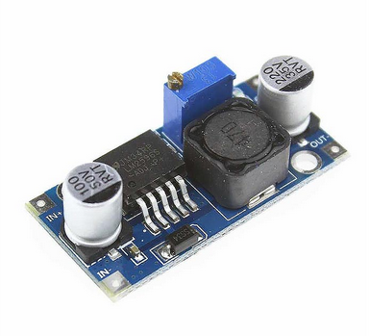

Figure 4.1 Step up & Step down converter module

In the overall system (robot and telecontroller), we have 12V 2900 mAh Lipo battery on the robot and 12V 900 mAh LiPo battery on the telecontroller.

## Telecommunication Subsystem

In the telecommunicatiıon subsytem, we made complete change in command sending system while keeping the video sending system the same.

For command sending system, we needed to change whole design presented in Conceptial Design Report due to legality issues. In the design described in Conceptual Design Report, we were using commercial FM radio frequencies (88 MHz-108MHz). However, according to BTK (Information Technologies Institution), civilians can not exceed RF power broadcast of 50 nW between this band[n]. We were using RF power level of 10 uW. So, we gave up on the system and developed a new system for command sending part of the telecommunication subsystem. We decided to use NRF24L01 RF tranciever modules for this purpose. The module uses 2.4 GHz frequency with its own protocol. The module is controlled by arduino interface. Setting up and testing the modules using procedures described in test procedures, we saw that the modules do satisfy our metrics. Test results are given in Table XX

Table 4‑1 Command sending system error rate

|  |  |  |  |  |  |  |
| --- | --- | --- | --- | --- | --- | --- |
| Distance (m) | 7 | 14 | 21 | 28 | 35 | 42 |
| Data Loss (bits) | 0% | 0% | 0% | 9% | 15% | 22% |

Observing Table XX, we concluded that the modules can provide us a proper operation for our robot.

For video sending systems, we only changed the antenna with high quality ones. With the new antennas, the operation range improved and became acceptable for our use. The test results given in Table XX justifies the operation.

Table 4‑2 Video quality test results

|  |  |  |  |  |  |  |
| --- | --- | --- | --- | --- | --- | --- |
| Distance (m) | 7 | 14 | 21 | 28 | 35 | 42 |
| Video Quality | Perfect | Perfect | Perfect | Perfect | Flickery | Flickery and Noisy |

Evaluating overall telecommunication subsystem, the whole system draws reasonable current, about 1.5 A, which is deliverable by a LiPo battery.

## Shooting Subsystem

In shooting subsystem, we needed to change to Plan B described in Conceptual Design Report which proposes a selenoid with a metal rod inside it. Because performing relevant tests, we saw that Plan A was not sufficient and the ball which is being shot could not be thrown at a certain distance. When we test both systems, the system in Plan A (which utilizes servo motor) can only achieve throw range of 10 cm while the system in Plan B (which utilizes selenoid) can achieve more than 1 meters. However, the selenoid draws more current than servo motor , about 800 mA, but this value is still within the range of deliverable current from a Lipo battery. Evaluating the results, we decided to use selenoid for shooting subsystem.

## Motion Subsystem

For motion subsystem, we stick with the plan A described in Conceptual Design Report which utilizes differential drive with two DC motors. Testing the motors, we evaluated that the speed and torque would be enough for a proper operation of our robot. Test results are given in Table Xx.

## Detection Subsystem

In our design, detection subsystem contains a single element which is the camera. Camera obtains the image of the surroundings and directly sends the image data to the transmitter. Our camera has 120 degrees of field of view. For cameras, 120 degrees of field of view is considered as ultrawide angle camera.[ https://en.wikipedia.org/wiki/Angle_of_view] So, we decided that ultrawide angle camera is sufficient for our operation and thus, we implemented it. In addition, our cameras resolution and color depth are 720x480 and 24bits respectively. These numbers are perfectly suitable for our project since we only use it for imaging relatively short distances (<2m).

# Comp

# Test Procedure

## Power

## Telecommunications Subsystem

For our final design, we followed following test procedure for command sending subsystem: performing command sending quality with certain ranges. We measure data loss per 100 commands. Simply comparing the values we obtained bit error rate. Obtained results are given in Table XX

|  |  |  |  |  |  |  |
| --- | --- | --- | --- | --- | --- | --- |
| Distance (m) | 7 | 14 | 21 | 28 | 35 | 42 |
| Data Loss (bits) | 0% | 0% | 0% | 9% | 15% | 22% |